**Assignment 1:** After the first run (*run0*), please report *Total cell area*, *Total Dynamic Power*, *Cell Leakage Power* and the worst (minimum) slack from the area, power and timing report files.

*Total cell area:*

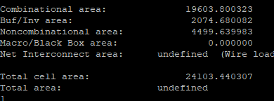

*Total Dynamic Power:*

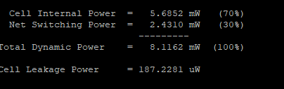

*Cell Leakage Power*

the worst (minimum) slack from the area

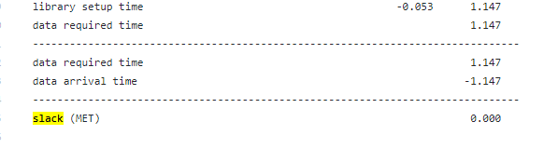

**Assignment 2:** Please open the library (.lib) files, and find and report PVT (process, voltage, temperature) conditions for each library. How does the fanout of four (FO4) delay of INVD8 vary between these libraries?

PVT for tcbn65gplustc.lib

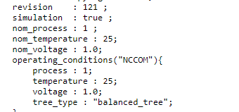

PVT for [tcbn65gplusbc.lib](https://github.com/blendid3/ECE26B_File/blob/master/tcbn65gplusbc.lib)

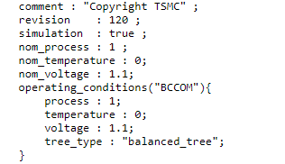

PVT for [tcbn65gpluswc.lib](https://github.com/blendid3/ECE26B_File/blob/master/tcbn65gpluswc.lib)

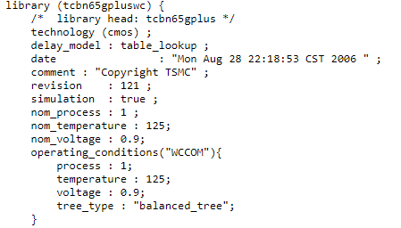

Fanout Delay for tcbn65gplustc.lib

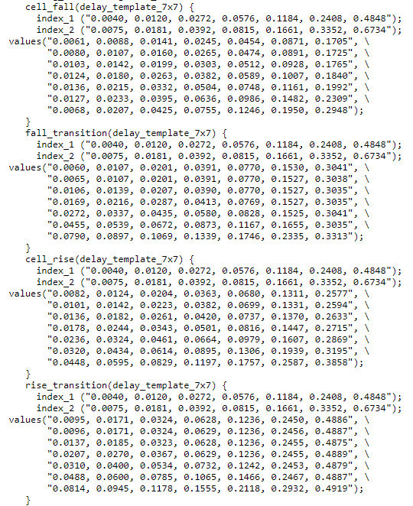

Fanout Delay for tcbn65gplusbc.lib

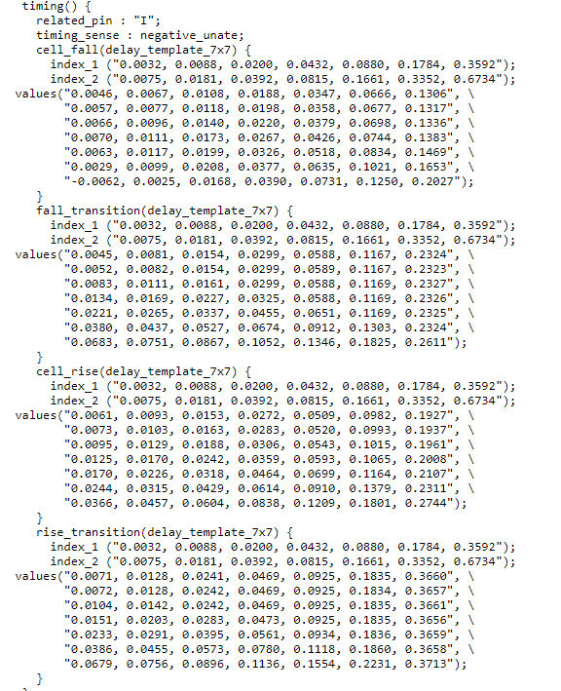

Fanout Delay for tcbn65gpluswc.lib

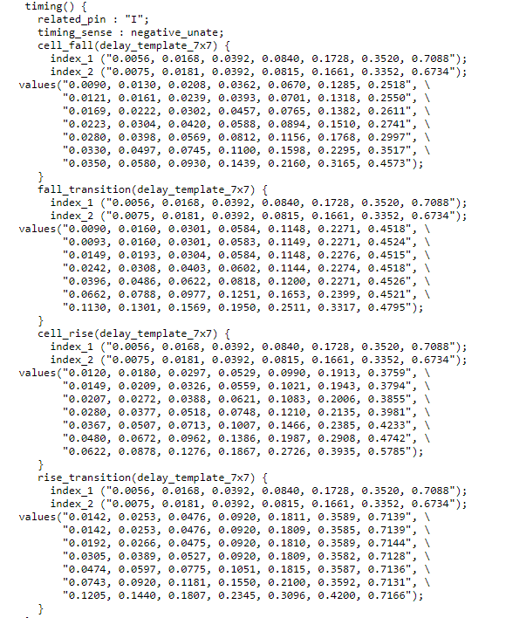

**Assignment 3:** Create two directories, *run_typ* and *run_bc*, and run synthesis by using typical and best condition libraries. Please report *Total cell area*, *Total Dynamic Power*, *Cell Leakage Power* and the worst slack for each condition. Please explain how area changes with the typical and best condition libraries versus that with the worst condition library. Why does the area change in that way?

*In the run_typ*

*Total cell area*

*Total Dynamic Power*

*Cell Leakage Power*

the worst slack

In the run_bc

*Total cell area*

*Total Dynamic Power*

*Cell Leakage Power*

the worst slack

Please explain how area changes with the typical and best condition libraries versus that with the worst condition library. Why does the area change in that way?

how area changes

in the run_bc

in the run_tc

in the run_wc

Why does the area change in that way?